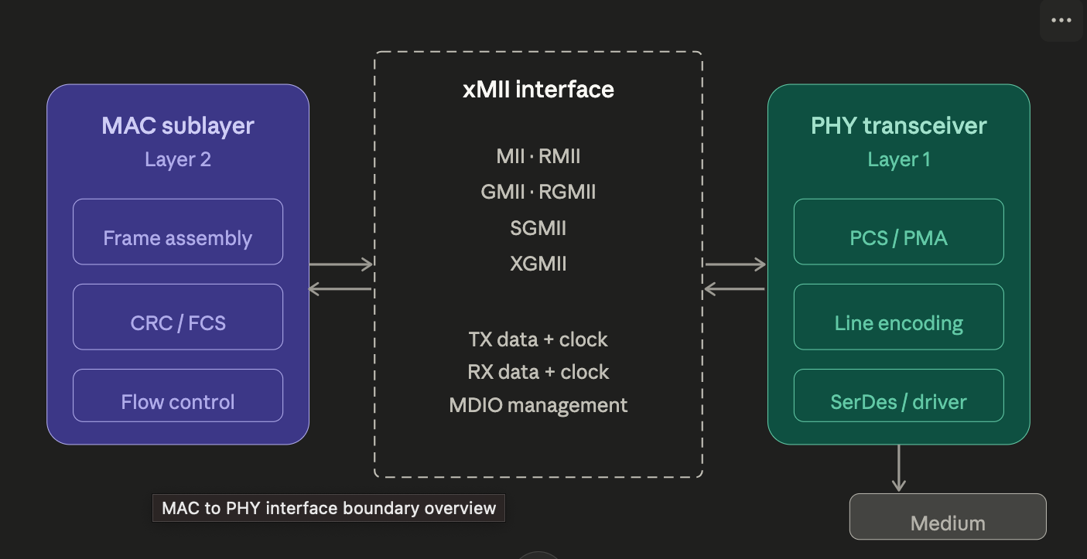
The MII family of interfaces all sit at the same architectural boundary: between the MAC sublayer (which handles framing, addressing, and access control) and the PHY transceiver (which handles encoding, signalling, and the physical medium). The interface standardises this boundary so that any compliant MAC can work with any compliant PHY — hence "Media Independent."

The key insight is that all these interfaces carry the same logical information — TX data, RX data, clock, and control signals — but they differ in how wide the data bus is, how fast the clock runs, and therefore how many physical pins are needed. The design trade-off is always: wider bus = simpler clocking but more pins and more PCB routing complexity.
Now let us see each interface's signal architecture in detail.
MAC INTERFACE SIGNAL ARCHITECTURE

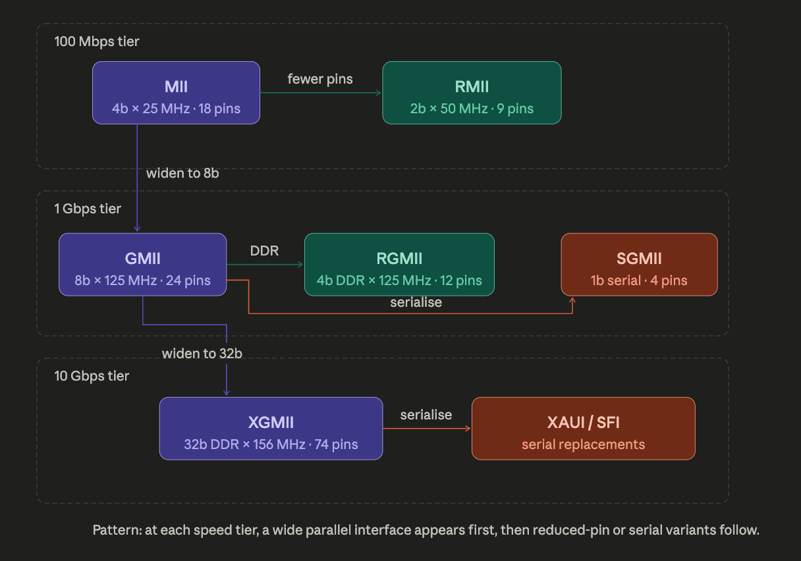

The fundamental equation is always throughput = data_width × clock_rate × DDR_factor. Every variant in the family manipulates these three variables differently to hit the target speed while optimising for pin count, PCB routing, or reach.
At 100 Mbps, MII (4b × 25 MHz, ~18 pins) was the original specification. RMII narrowed the bus to 2 bits and doubled the clock to 50 MHz, halving the pin count to ~9. RMII also eliminated the two separate PHY-sourced clocks in favour of a single external 50 MHz reference — a subtle but important change, since it means the MAC no longer needs to handle clock domain crossing from the PHY.
At 1 Gbps, three competing philosophies emerged. GMII scaled MII straightforwardly to 8b × 125 MHz but at ~24 pins became expensive to route on multi-layer PCBs. RGMII introduced DDR signalling — sampling on both clock edges — so a 4-bit bus at 125 MHz achieves the same effective 8-bit throughput with only 12 pins. The 2 ns internal delay specification (RGMII-ID) is a persistent source of board bring-up issues; whether the delay is applied at the MAC, the PHY, or on the PCB traces must be consistent. SGMII went fully serial: a 1.25 Gbaud differential pair using 8b/10b encoding, with speed negotiation handled in-band. This is the dominant interface for switch ASICs and SFP module cages.
At 10 Gbps, XGMII widened to 32 bits with DDR (effectively 64 bits per cycle at 156.25 MHz), but the ~74 pin count made it viable only as an internal chip-to-chip interface over very short traces. In practice, it was quickly superseded by serial alternatives: XAUI (four 3.125 Gbaud lanes) and SFI/XFI (single 10.3125 Gbaud lane).
The recurring pattern: at each speed tier, a wide parallel interface appears first as the conceptually simple extension, then reduced-pin and serial variants follow as the industry optimises for cost and board density. In modern designs, RGMII dominates at 1G for cost-sensitive embedded applications, SGMII dominates for switch-to-PHY connections, and everything at 10G and above is serial.

